How to make the Vibration Actuator

Parts Needed

|  |  |  |
| --- | --- | --- |
| Sr No. | Name | Link |
| 1 | Particle photon | [www.Particle.io](http://www.spark.io) |
| 2 | Adafruit Micro Lipo w/MicroUSB Jack - USB LiIon/LiPoly charger | <http://www.adafruit.com/products/1904> |
| 3 | Particlefun 850 mAh Li-Ion Battery | [https://www.Particlefun.com/products/341](https://www.sparkfun.com/products/341) |
| 4 | Vibration Motor | [https://www.Particlefun.com/products/8449](https://www.sparkfun.com/products/8449) |

Circuit Diagrams to build Vibration Actuators using Particle Photons

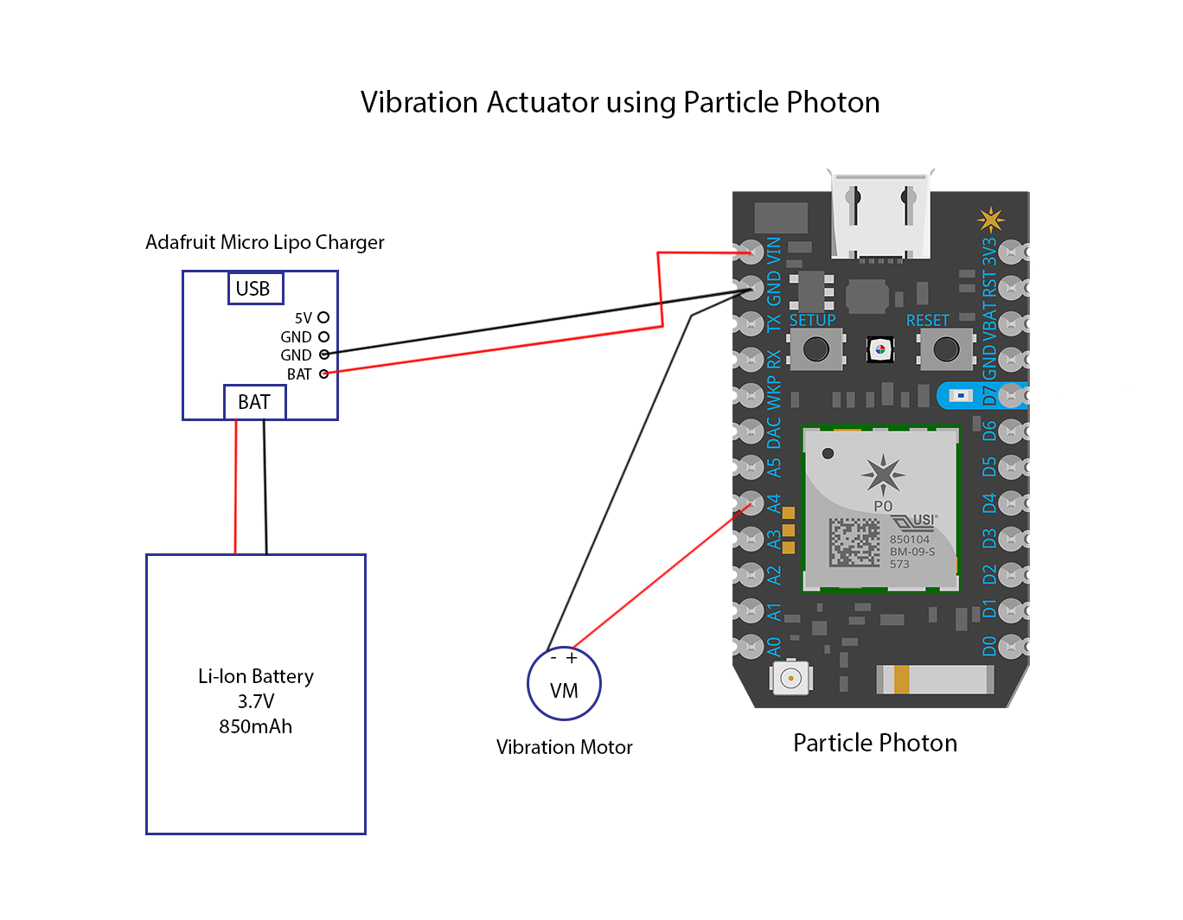

Instructions to build actuators using Particle Photon

1. Desolder all the pins on the Particle Photons and take them out.
2. Connect the Battery charger to the Particle Photon by connecting the Bat pin to the VIN pin and the GND pin to the GND pin on the Particle Photon. Do not connect the battery to the battery charger while soldering short circuits might happen.
3. Solder the 500mA slot on the battery charger. This will Speed up the charging as it allow more current for charging the battery.
4. Connect the red wire (positive) of the vibration motor to the pin A4 of the Particle Photon and the blue wire (Ground) to the GND pin of the Particle Photon.
5. Once everything is soldered, you can connect the battery to the battery charger and see if the Particle Photon powers on. This can be confirmed by looking at the light on the Particle Photon.
6. If you haven’t used a Particle Photon before, follow the instructions on [http://docs.Particle.io/](http://docs.spark.io/) to learn how to flash the Particle Photon. Important tip, once you have soldered the Particle Photon, only power the Particle Photon using the battery charger. If the battery has no charge you can charge the battery/ power the Photon by any USB power source by connecting the USB cable to the Micro USB port of the battery charger. If you haven’t soldered the Particle Photon, then you can use the micro USB connector on the Particle Photon itself to power the Photon for flashing new code on it.
7. You can find the code for the Particle Photon in the package folder. You can use the Cloud API of Particle to flash the Photons. Once the photon is flashed, we are disconnecting it from the cloud, so to reflash the photon with any updated code, you have to put the Photon in Safe Mode to update the code on the Particle Photon. Once the photon is in Safe Mode, you can update the Photon as mentioned above. To put the photon in safe mode, follow the instructions on the website <https://docs.particle.io/guide/getting-started/modes/photon/#safe-mode> It is highly recommended to play with the Particle Photon before using it for this project so you get an idea of it’s working.
8. Once the Photon is flashed and the Photon is running without any problems, you can 3d Print the boxes and the lid from the files given in the folder and then put the circuit into the box. It should be assembled as shown in the picture below (Image is of a Particle Photon but it will be same for photon).

Put the battery in the box and cover with the lid.

